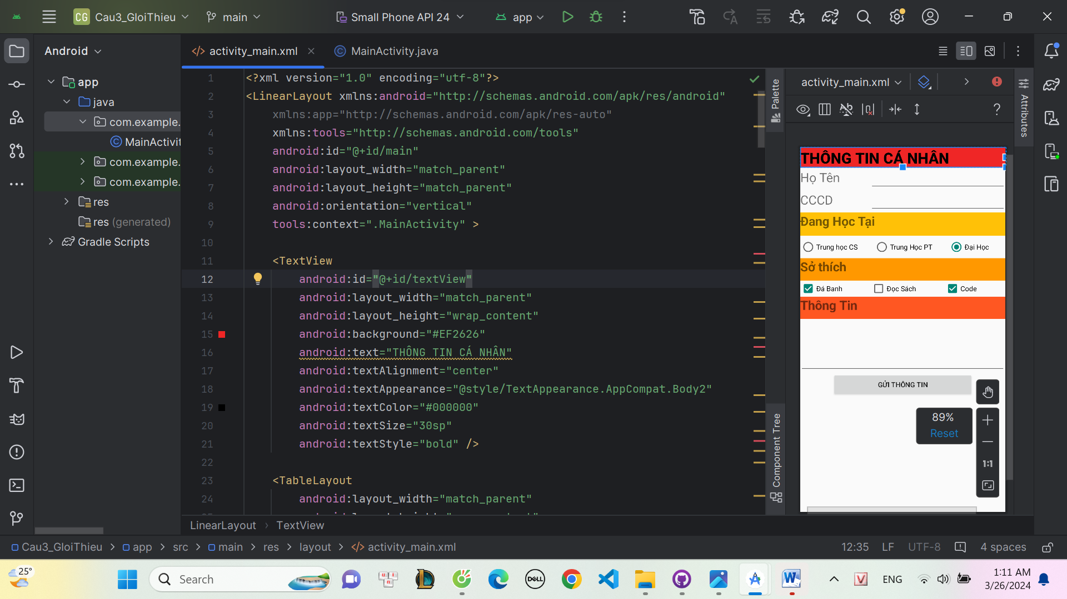

<?xml version="1.0" encoding="utf-8"?>  
<LinearLayout xmlns:android="http://schemas.android.com/apk/res/android"  
 xmlns:app="http://schemas.android.com/apk/res-auto"  
 xmlns:tools="http://schemas.android.com/tools"  
 android:id="@+id/main"  
 android:layout_width="match_parent"  
 android:layout_height="match_parent"  
 android:orientation="vertical"  
 tools:context=".MainActivity" >  
  
 <TextView  
 android:id="@+id/textView"  
 android:layout_width="match_parent"  
 android:layout_height="wrap_content"  
 android:background="#EF2626"  
 android:text="THÔNG TIN CÁ NHÂN"  
 android:textAlignment="center"  
 android:textAppearance="@style/TextAppearance.AppCompat.Body2"  
 android:textColor="#000000"  
 android:textSize="30sp"  
 android:textStyle="bold" />  
  
 <TableLayout  
 android:layout_width="match_parent"  
 android:layout_height="wrap_content"  
 android:stretchColumns="*">  
  
 <TableRow  
 android:layout_width="match_parent"  
 android:layout_height="match_parent">  
  
 <TextView  
 android:id="@+id/textView2"  
 android:layout_width="wrap_content"  
 android:layout_height="wrap_content"  
 android:text="Họ Tên"  
 android:textSize="25sp" />  
  
 <EditText  
 android:id="@+id/edtht"  
 android:layout_width="wrap_content"  
 android:layout_height="wrap_content"  
 android:ems="10"  
 android:inputType="text" />  
 </TableRow>  
  
 <TableRow  
 android:layout_width="match_parent"  
 android:layout_height="match_parent">  
  
 <TextView  
 android:id="@+id/textView3"  
 android:layout_width="wrap_content"  
 android:layout_height="wrap_content"  
 android:text="CCCD"  
 android:textSize="25sp" />  
  
 <EditText  
 android:id="@+id/edtCCCD"  
 android:layout_width="wrap_content"  
 android:layout_height="wrap_content"  
 android:ems="10"  
 android:inputType="text" />  
 </TableRow>  
  
 </TableLayout>  
  
 <TextView  
 android:id="@+id/textView8"  
 android:layout_width="match_parent"  
 android:layout_height="47dp"  
 android:background="#FFC107"  
 android:text="Đang Học Tại"  
 android:textAlignment="center"  
 android:textSize="25sp"  
 android:textStyle="bold" />  
  
 <RadioGroup  
 android:id="@+id/idgroup"  
 android:layout_width="match_parent"  
 android:layout_height="wrap_content"  
 android:orientation="horizontal">  
  
 <RadioButton  
 android:id="@+id/radioButton7"  
 android:layout_width="wrap_content"  
 android:layout_height="wrap_content"  
 android:layout_weight="1"  
 android:text="Trung học CS" />  
  
 <RadioButton  
 android:id="@+id/radioButton8"  
 android:layout_width="wrap_content"  
 android:layout_height="45dp"  
 android:layout_weight="1"  
 android:text="Trung Học PT" />  
  
 <RadioButton  
 android:id="@+id/radioButton9"  
 android:layout_width="wrap_content"  
 android:layout_height="wrap_content"  
 android:layout_weight="1"  
 android:checked="true"  
 android:text="Đại Học" />  
 </RadioGroup>  
  
 <TextView  
 android:id="@+id/textView8"  
 android:layout_width="match_parent"  
 android:layout_height="45dp"  
 android:background="#FF9800"  
 android:text="Sở thích"  
 android:textAlignment="center"  
 android:textSize="25sp"  
 android:textStyle="bold" />  
  
 <LinearLayout  
 android:layout_width="match_parent"  
 android:layout_height="wrap_content"  
 android:orientation="horizontal">  
  
 <CheckBox  
 android:id="@+id/cbdb"  
 android:layout_width="wrap_content"  
 android:layout_height="wrap_content"  
 android:layout_weight="1"  
 android:checked="true"  
 android:text="Đá Banh" />  
  
 <CheckBox  
 android:id="@+id/cbds"  
 android:layout_width="wrap_content"  
 android:layout_height="wrap_content"  
 android:layout_weight="1"  
 android:text="Đọc Sách" />  
  
 <CheckBox  
 android:id="@+id/cbcd"  
 android:layout_width="wrap_content"  
 android:layout_height="wrap_content"  
 android:layout_weight="1"  
 android:checked="true"  
 android:text="Code" />  
 </LinearLayout>  
  
 <TextView  
 android:id="@+id/textView8"  
 android:layout_width="match_parent"  
 android:layout_height="45dp"  
 android:background="#FF5722"  
 android:text="Thông Tin "  
 android:textAlignment="center"  
 android:textSize="25sp"  
 android:textStyle="bold" />  
  
 <EditText  
 android:id="@+id/edtbosung"  
 android:layout_width="match_parent"  
 android:layout_height="wrap_content"  
 android:ems="10"  
 android:gravity="start|top"  
 android:minLines="4"  
 android:inputType="textMultiLine" />  
  
 <Button  
 android:id="@+id/button"  
 android:layout_width="282dp"  
 android:layout_height="wrap_content"  
 android:layout_gravity="center"  
 android:text="Gửi thông tin" />  
  
</LinearLayout>